**User Manual**

The Application contains two main pages for two features:

**Pronunciation Assist (PA) page:**

**Dictionary Audio Downloader (DAD) page:**

1. Setup:

The application is written in Python and uses Streamlit to create a webpage. The necessary libraries are listed in the file ‘used_library.txt’.

To run Streamlit webpage, using this command in cmd:

PA page: **streamlit run test.py**

DAD page: **streamlit run get_dict.py**

2. Dictionary Audio Downloader (DAD) page:

When using this feature, the system will download an audio file of a word from a dictionary. Currently, we have selected the Cambridge Dictionary (https://dictionary.cambridge.org/). The downloaded audio file will be used as the standard audio file for comparisons in the PA app. The file will be saved in ‘cam_audio’ folder.

Input a word to download from dictionary

Download Successful (.mp3 format)

The downloaded file will be in .mp3 format (as provided by the Cambridge Dictionary); however, for use in comparisons in the PA app, it needs to be converted to .wav format. Therefore, the application includes a button to convert the file from .mp3 to .wav format.

MP3 to WAV converter

Convert Successful

After successfully converting the format, the WAV file will be saved in the same folder as the MP3 file (the 'cam_audio' folder).

Finally, the ‘**Delete All**’ button is used to delete all current audio files in the 'cam_audio' folder.

3. Pronunciation Assist (PA) page:  
In the initial step, the application will have two buttons:

* **'Choose audio file for standard'**: Select a file to serve as the standard. (File downloaded from DAD application)
* **'Recording Audio'**: Record the user's pronunciation of the uploaded word.
* **'Compare'**: Compare the two audio segments to calculate their similarity. The higher the score, the greater the similarity and the more accurate the pronunciation.

Upload an audio file and record that word

Upload successfully and ready to compare

By pressing the button, the two audio segments will be compared to calculate their similarity.

* If the recorded audio does not match the word chosen as the standard, the system will assign a score of 0 and display "Maybe wrong word?".
* If the recorded audio matches the word chosen as the standard, the system will calculate the similarity:
  + If the similarity is below 50, the system will display "Need a lot of improvement!".
  + If the similarity is between 50 and 75, the system will display "Understandable!".
  + If the similarity is above 75, the system will display "Well Done!" indicating good pronunciation.

Comparison Score

Furthermore, you can select 'Analyze Results' to display detailed comparison results. Finally, similar to the DAD application, there is a 'Delete All' button to delete all temporary audio files in the application.

More details on recording compared to standard audio files

Additionally, the application can recognize vowels and consonants from the two uploaded audio files (the Cambridge audio file and the recorded audio file) and compare their similarities.

For each audio file, an analysis will be conducted, resulting in a table of values indicating the positions of the sounds in IPA (International Phonetic Alphabet) format. This includes the start and end positions of the corresponding sounds, with consonants labeled in green and vowels labeled in red.

For the recorded audio file, there will be an additional column for similarity, comparing the similarity of the corresponding sound segments (start and end) with the standard audio file.

Vowel and Consonant Analyze

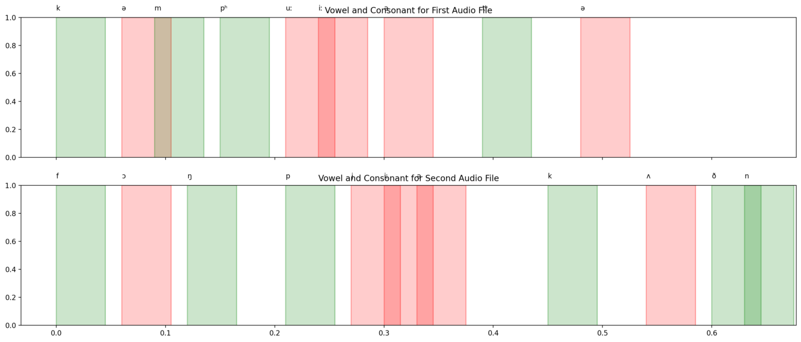

Finally, two result tables will be displayed, providing a visual comparison of the user's pronunciation (the second table) with the standard audio from the Cambridge Dictionary (the first table). These tables will include the positions of vowels and consonants.